**Minimum number of moves required to reach the destination by the king in a chess board**

Given four integers **sourceX**, **sourceY**, **destinationX** and **destinationY** which represent the source and destination coordinates on a chessboard. The task is to find the minimum number of moves required by the **king** to reach from source to destination.   
A king can move to the square that has a common side or a common vertex with the square the king is currently in (generally there are 8 different squares he can move to).

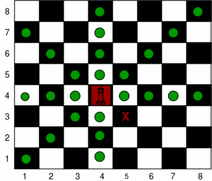

Print path using L, R, U, D, LU, LD, RU and RD where L, R, U and D represent left, right, up and down respectively.

**Examples:**

|  |
| --- |
| ***Input:****sourceX = 4, sourceY = 4, destinationX = 3, destinationY = 5* ***Output:****1  DR*  ***Input:****sourceX = 4, sourceY = 4, destinationX = 7, destinationY = 0* ***Output:****4  UL  UL  UL  L* |

**Approach:** Move in the diagonal direction towards the destination until the king reaches same column or same row as the destination, then move towards the destination in a straight line.

Below is the implementation of the above approach:

***Time complexity:*** O(max(a, b)), where a = sourceX and b = sourceY

***Auxiliary Space:*** O(1)